Day 6

--1.Categorize products by stock status

--(Display product_name, a new column stock_status whose values are based on below condition

-- units_in_stock = 0 is 'Out of Stock'

-- units_in_stock < 20 is 'Low Stock')

select product_name,

case

when units_in_stock = 0 then 'Out of Stock'

when units_in_stock < 20 then 'Low Stock'

else 'no stock'

end as stock_status

from products;

Output

--2Find All Products in Beverages Category

--(Subquery, Display product_name,unitprice)

select product_name,unit_price

from products

where category_id=(

select category_id

from categories

WHERE category_name = 'Beverages'

);

Output:

3.Find Orders by Employee with Most Sales

--(Display order_id, order_date, freight, employee_id.

--Employee with Most Sales=Get the total no.of of orders for each employee then order by DESC and limit 1. Use Subquery)

select order_id,order_date,freight,employee_id

from orders

where employee_id=(

select employee_id

from(

select employee_id, count(*) as totalorders

from orders

group by employee_id

order by totalorders desc

limit 1) as top_employee

);

Output

---4.Find orders where for country!= ‘USA’ with freight costs higher than any order from USA. (Subquery, Try with ANY, ALL operators)

select order_id,order_date,freight,ship_country

from orders

where ship_country!='USA'

and freight>any(

select freight

from orders

where ship_country='USA');

output

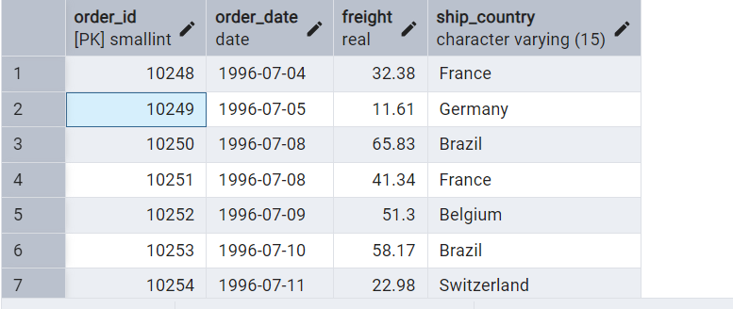

select order_id,order_date,freight,ship_country

from orders

where ship_country!='USA'

and freight>all(

select freight

from orders

where ship_country='USA');

output

